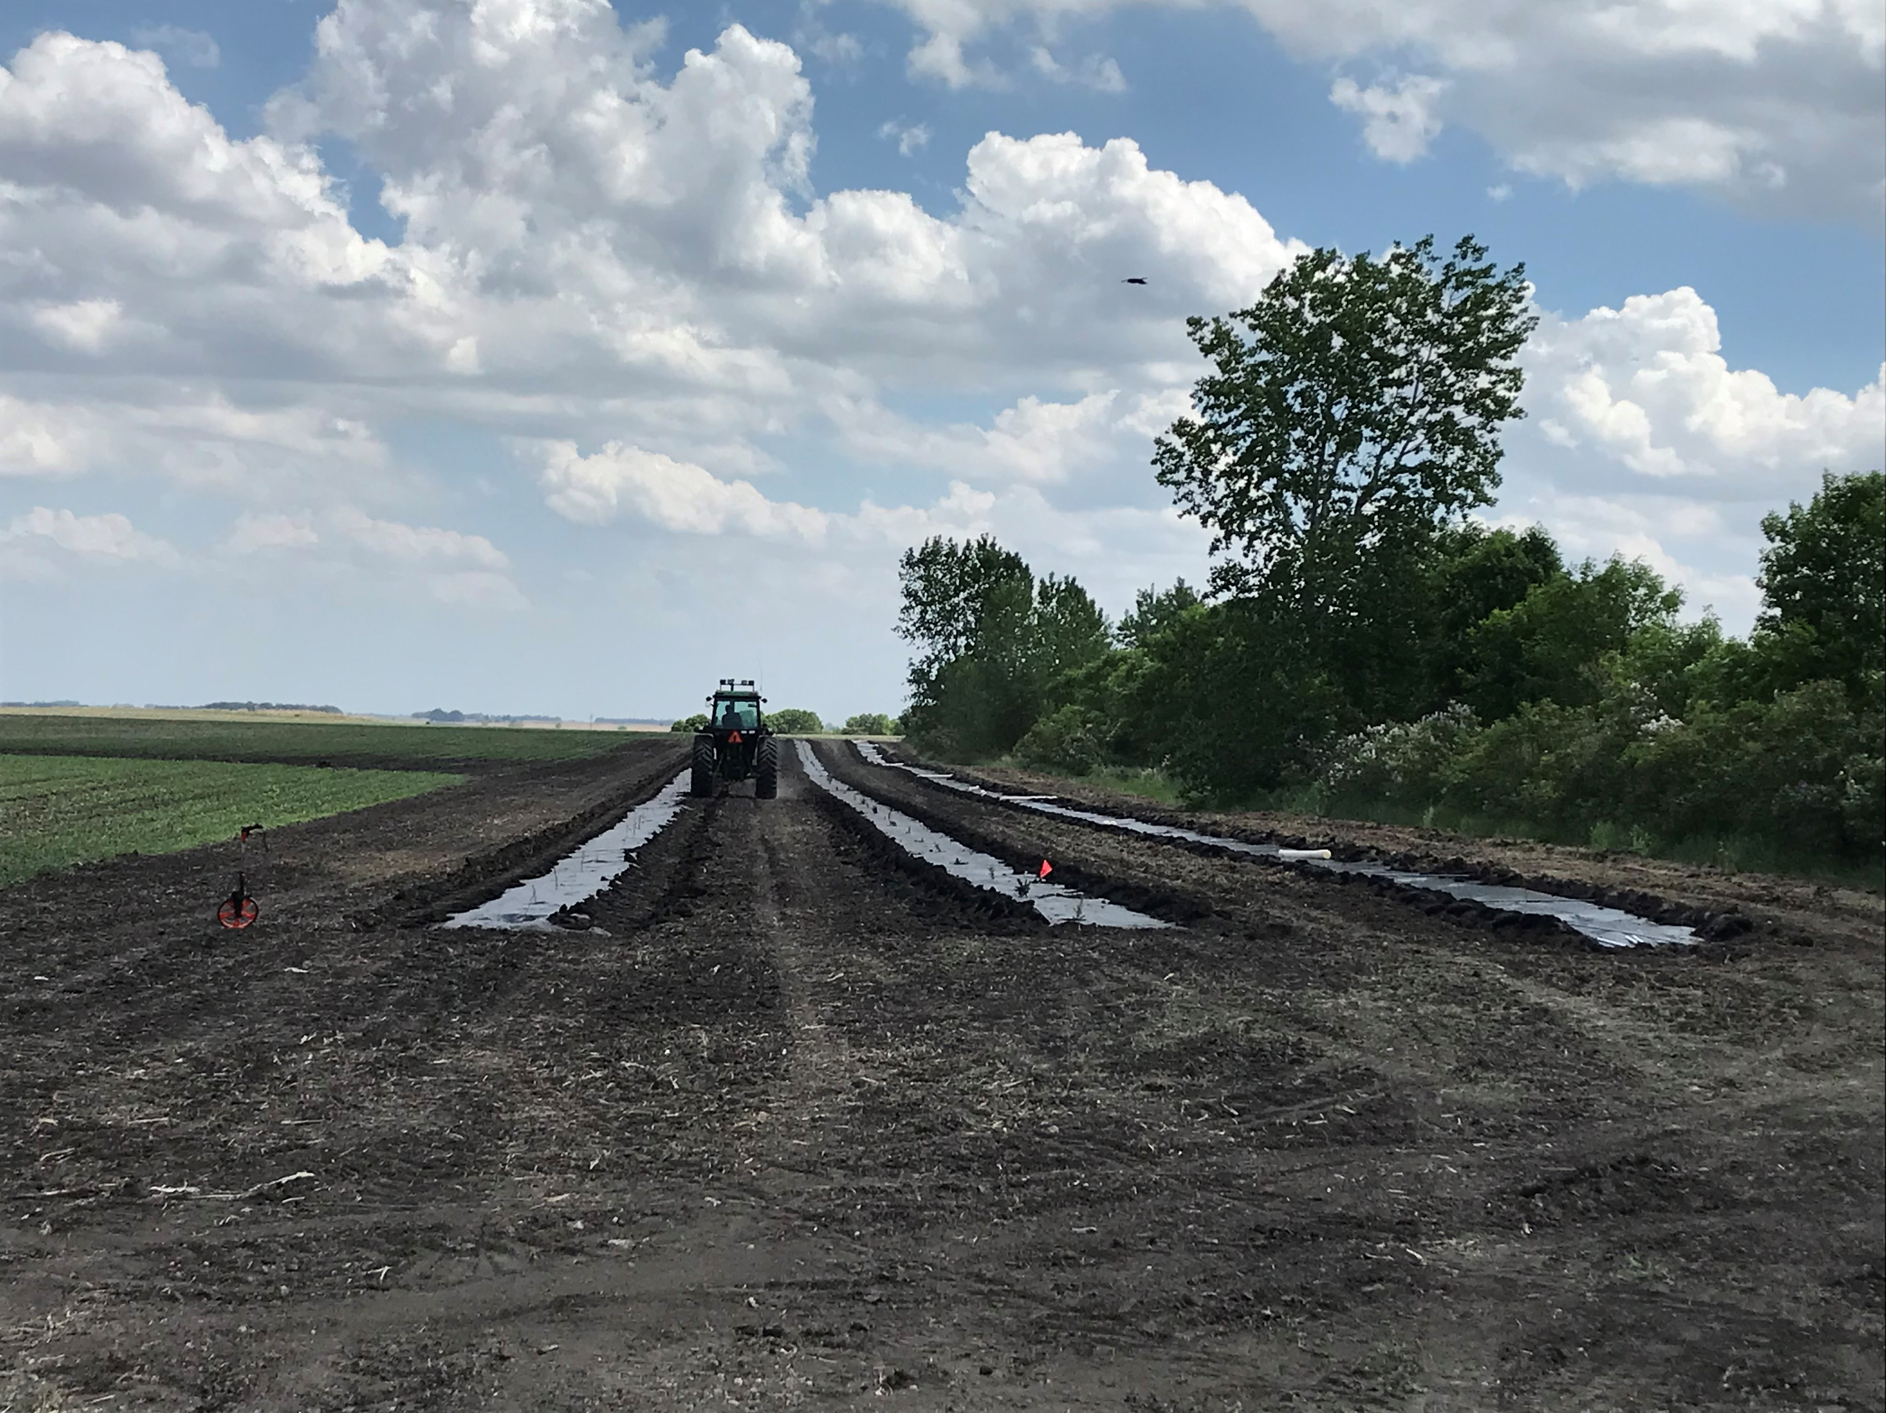

2023 Progress
Report

Roberts Conservation District
By Kristin Pester
District Manager

Table of Contents
Roberts Conservation Distirct……………………………………….1
Board Members………………………………………………………………..2
Crew…………………………………………………………………………….3
Awards………………………………………………………………………….4
Arbor Day…………………………………………………………………….…5
Arbor Day……………….……………………………………………………..6
Outreach………………………………………………………………7-10
Services Report…………………………………………………………11

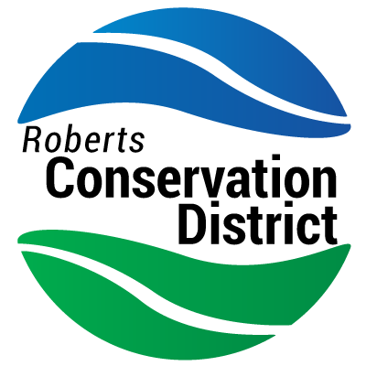
- Conservation Districts were organized over 80 years ago. Roberts Conservation District (RCD) was established in 1941. The idea behind conservation districts is to coordinate assistance from all available resources- public, private, local, state, and federal entities- in effort to develop locally led solutions to natural resource concerns.
- Conservation Districts are self-funded entities, always looking for new opportunities and methods to use in the conservation field while supporting their own business. Without the public’s interaction, conservation districts would fail, so it is important to have an incredible relationship with the inhabitants of our county.

District Staff
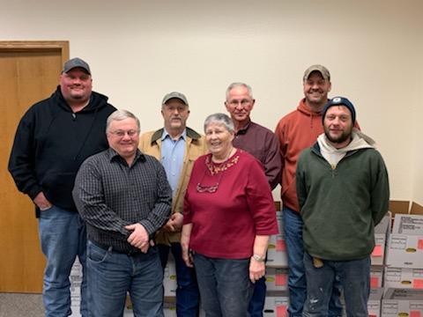

District Staff | Position
Calvin Thompson | Chairman
Tim Gleason | Vice Chair
Cody Hanson | Supervisor
Lee Solberg | Supervisor
Ben Hanson | Supervisor
Duane Schneider | Advisor
June Helgeson | Advisor
Kristin Pester | Dist. Mgr.
Carrie Ewalt  (left Oct 2023) | Resource Tech
Ron Christensen | Drill Operator

Mission Statement

Roberts Conservation District serves to encourage the preservation of our natural resources by providing educational, technical, and financial resources to the landowners, residents, and visitors we serve.

Board members

Conservation district supervisors are elected by the people to represent their interest in natural resources conservation. Supervisors are leaders, using their own operations to set a good conservation example to others and demonstrate conservation practices.
Pictured left to right. Back row: Ben Hanson Supervisor, Duane Schneider Advisor, Calvin Thompson Chairman, Cody Hanson Supervisor. Front Row left to right: Tim Gleason Supervisor, June Helgeson Advisor, and Lee Solberg Supervisor.

Crew Members
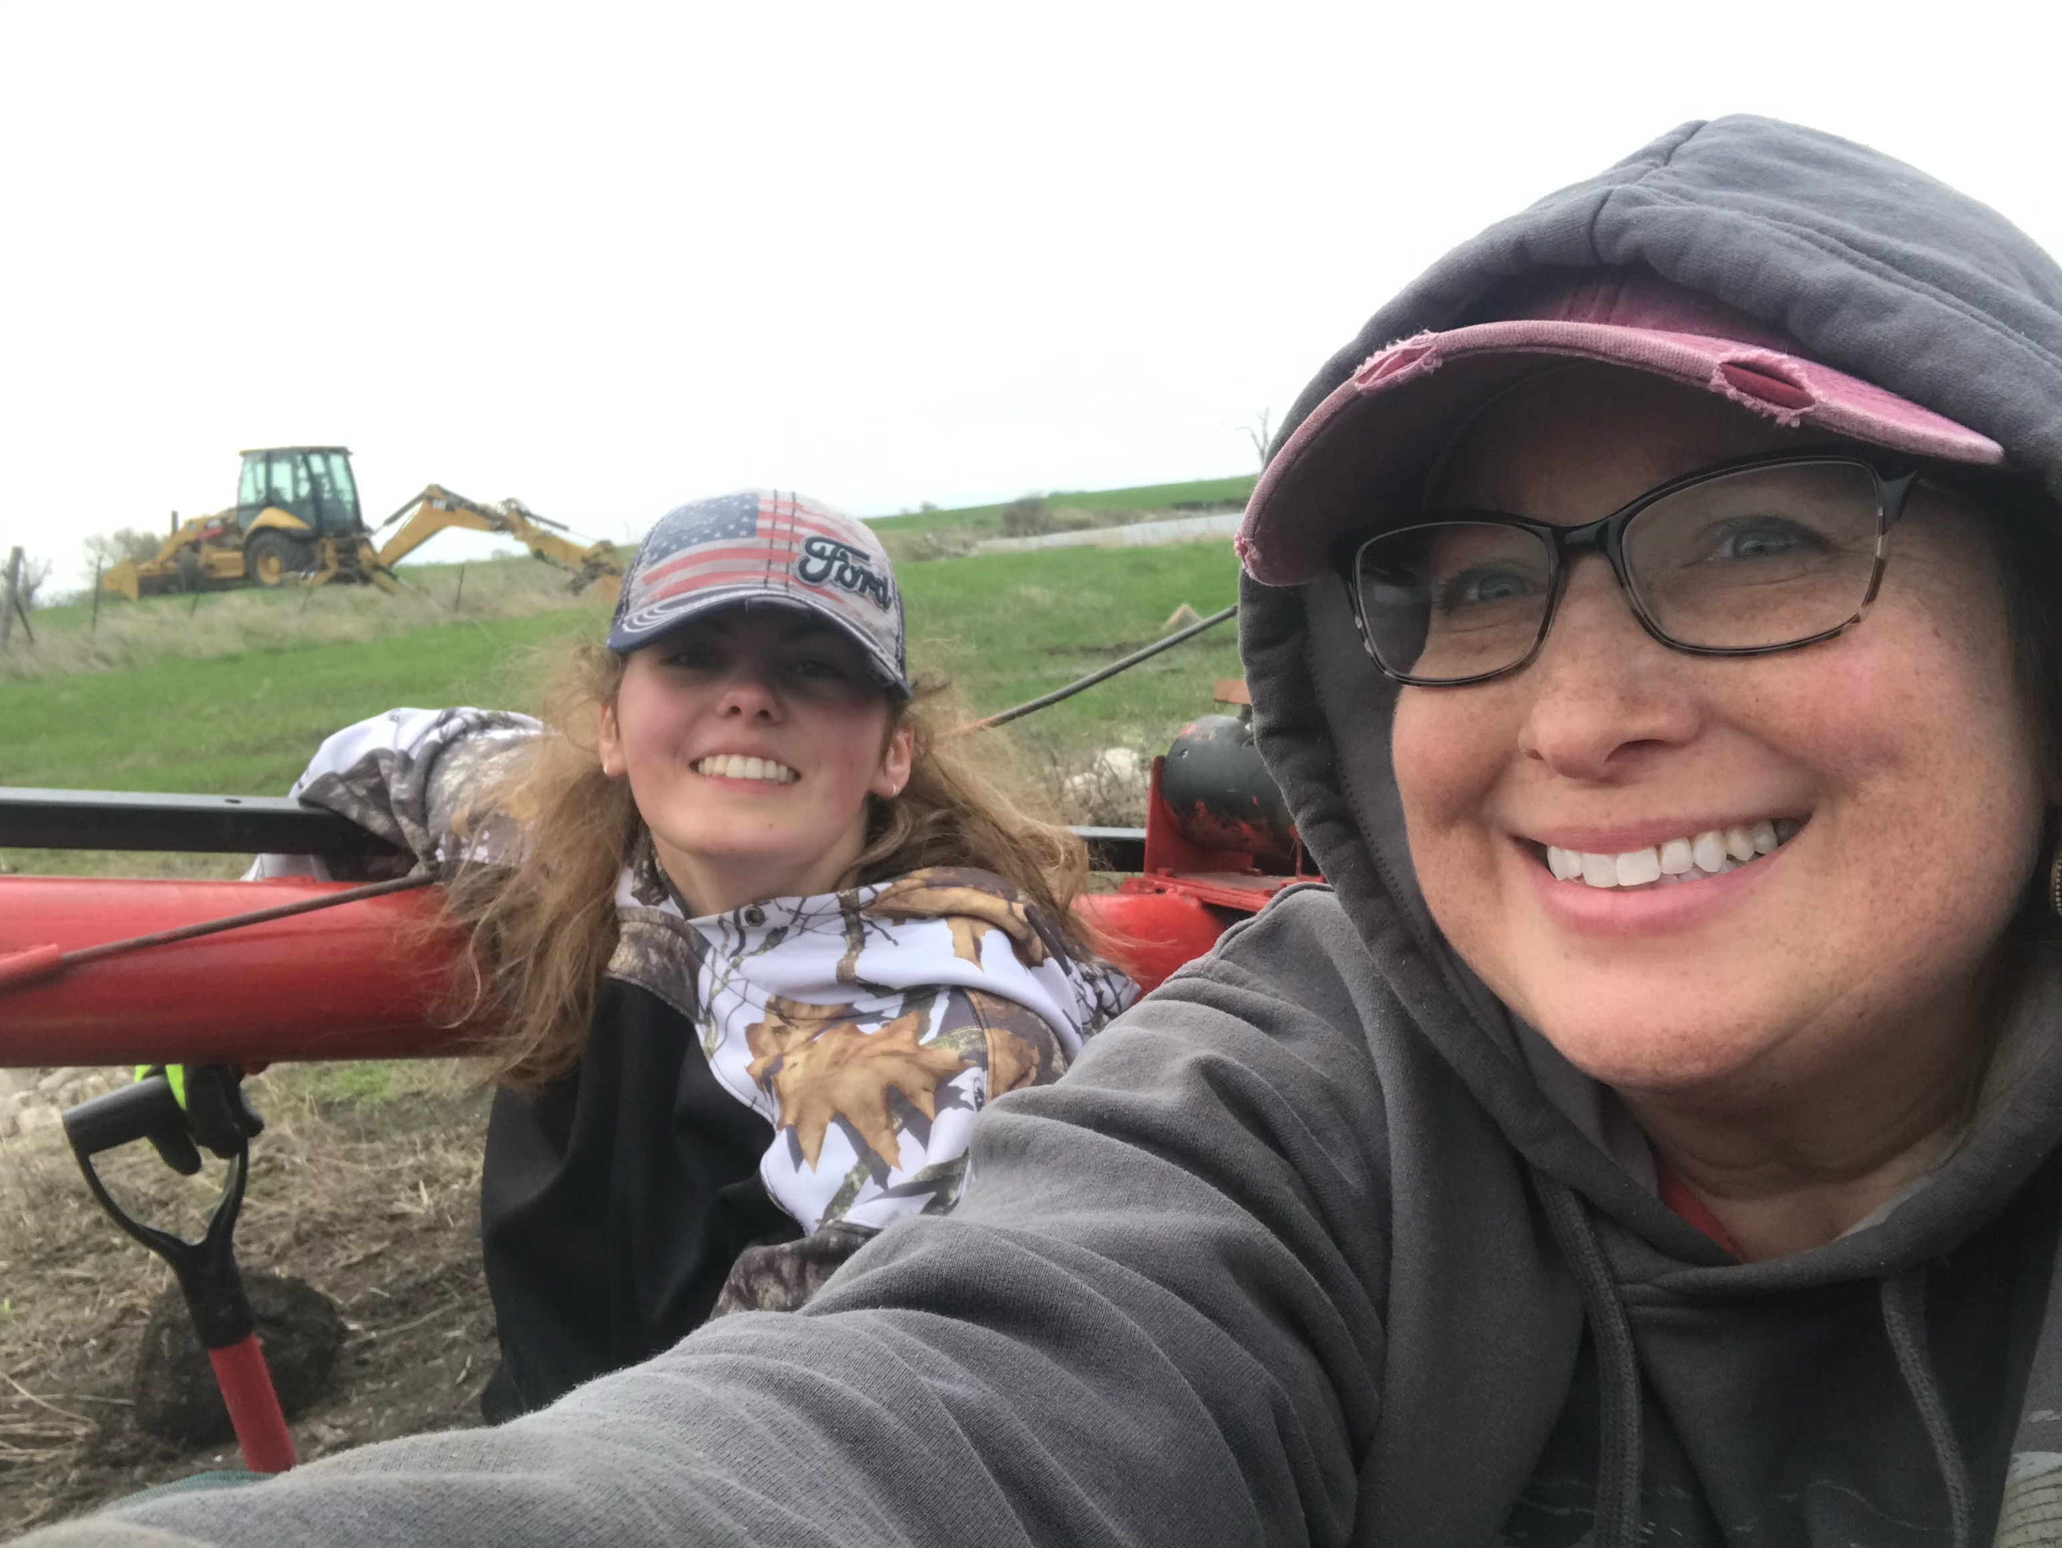
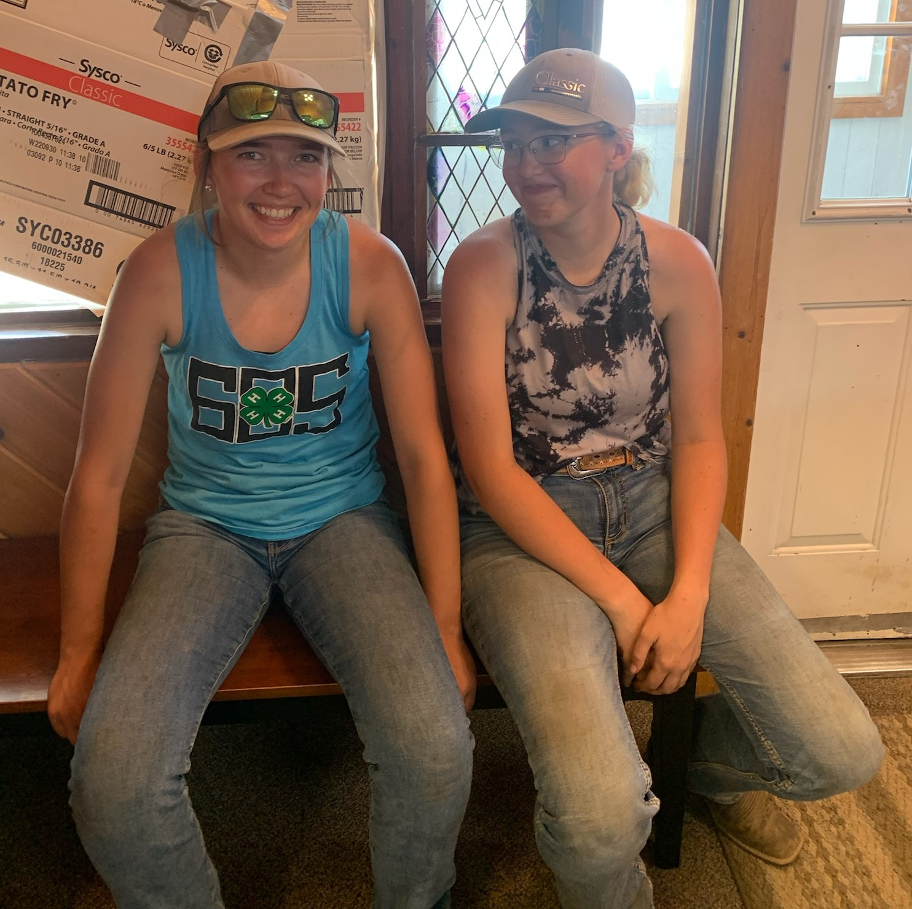

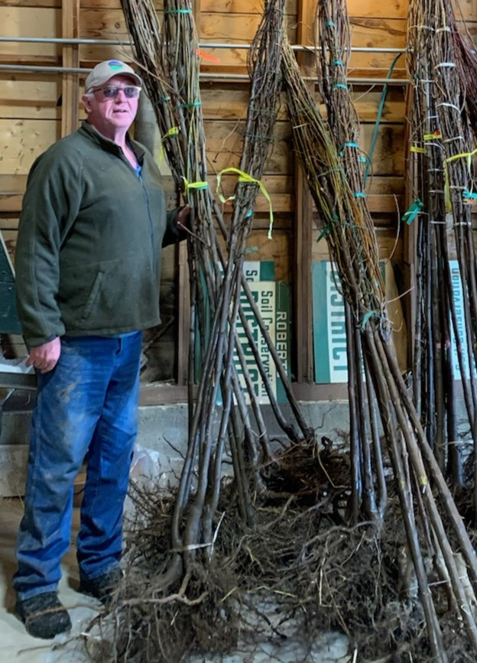

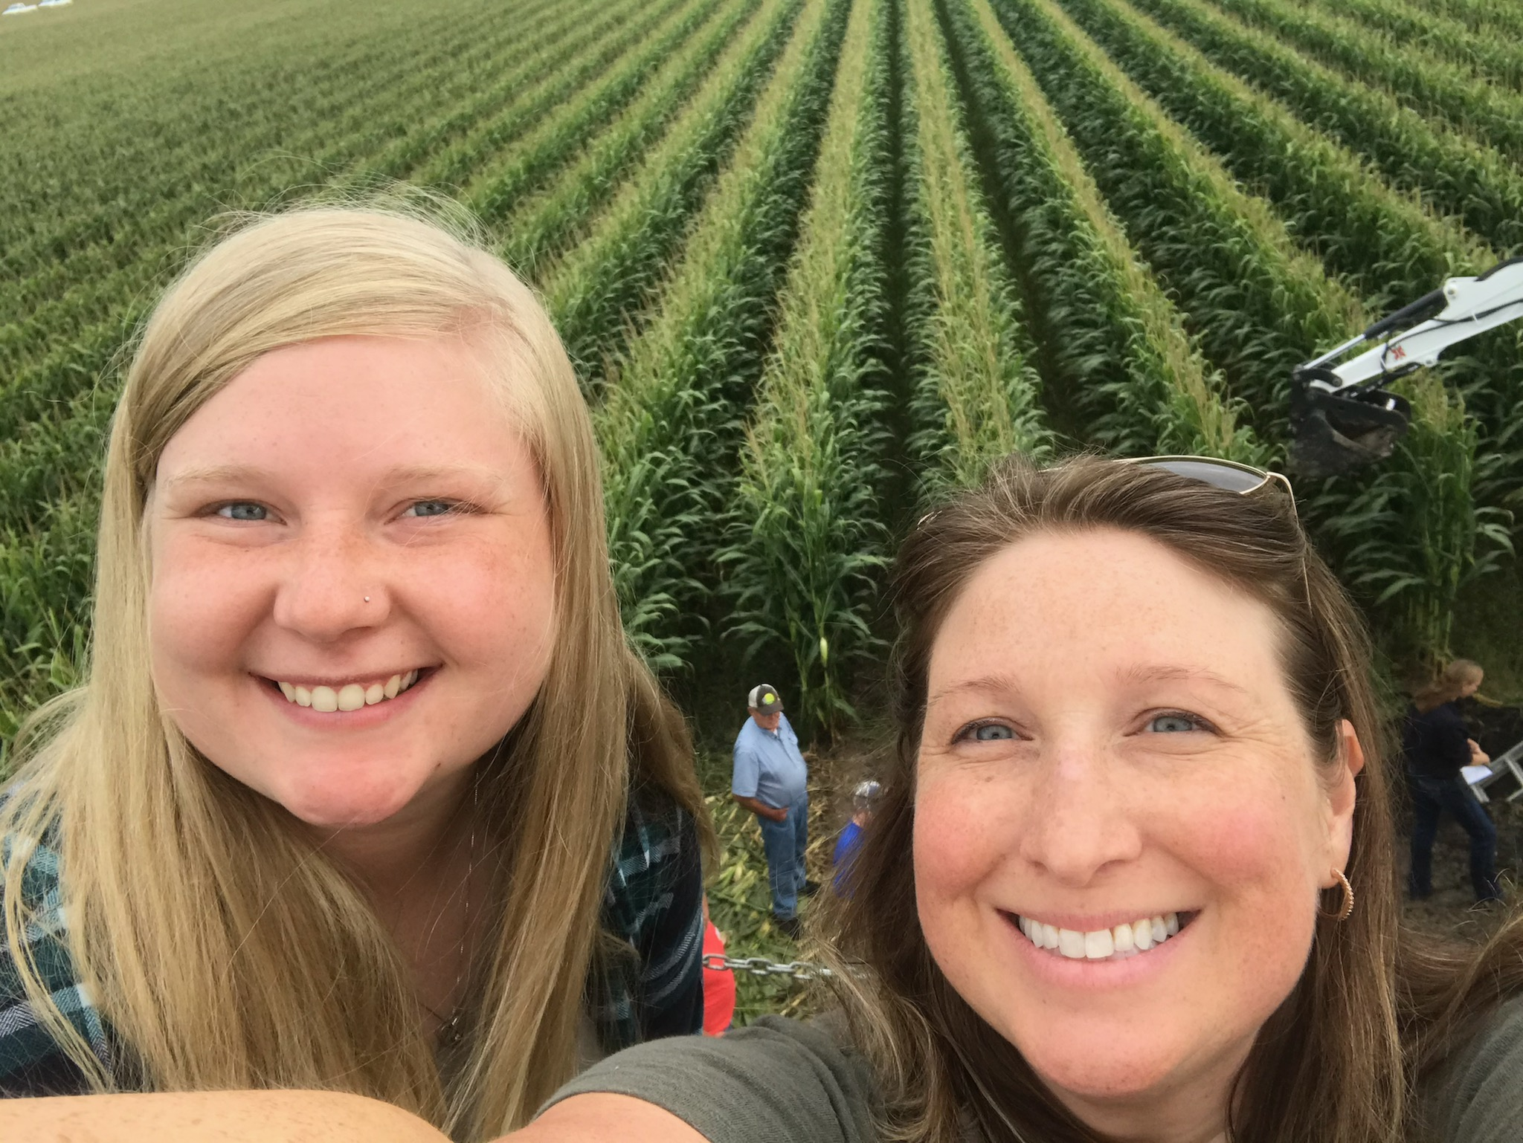

Soil Conservation Winner
Roberts Conservation District Board Members presenting the 2023 South Dakota Soil Conservation Farm/Ranch Award to 4th generational farmer, Alan Schmidt. Alan has been an active participant in both CSP and CRP programs offered through NRCS & FSA. He has readily implemented conservation practices, many of which target the principles of soil health: reducing tillage or no-tilling fields, crop rotation which includes a small grain component, selecting cover crops which promote soil health, as well as adding livestock to his fields for end of season grazing.

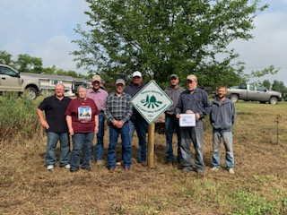

Speech Contest
Kate Meyer, a sophomore at Sisseton High School, and Hunter Biel, a junior at Sisseton High School both received an award from the Roberts Conservation District for the 2023 Speech Contest. The theme was “Backyard Conservation: Don’t Water it Down”.

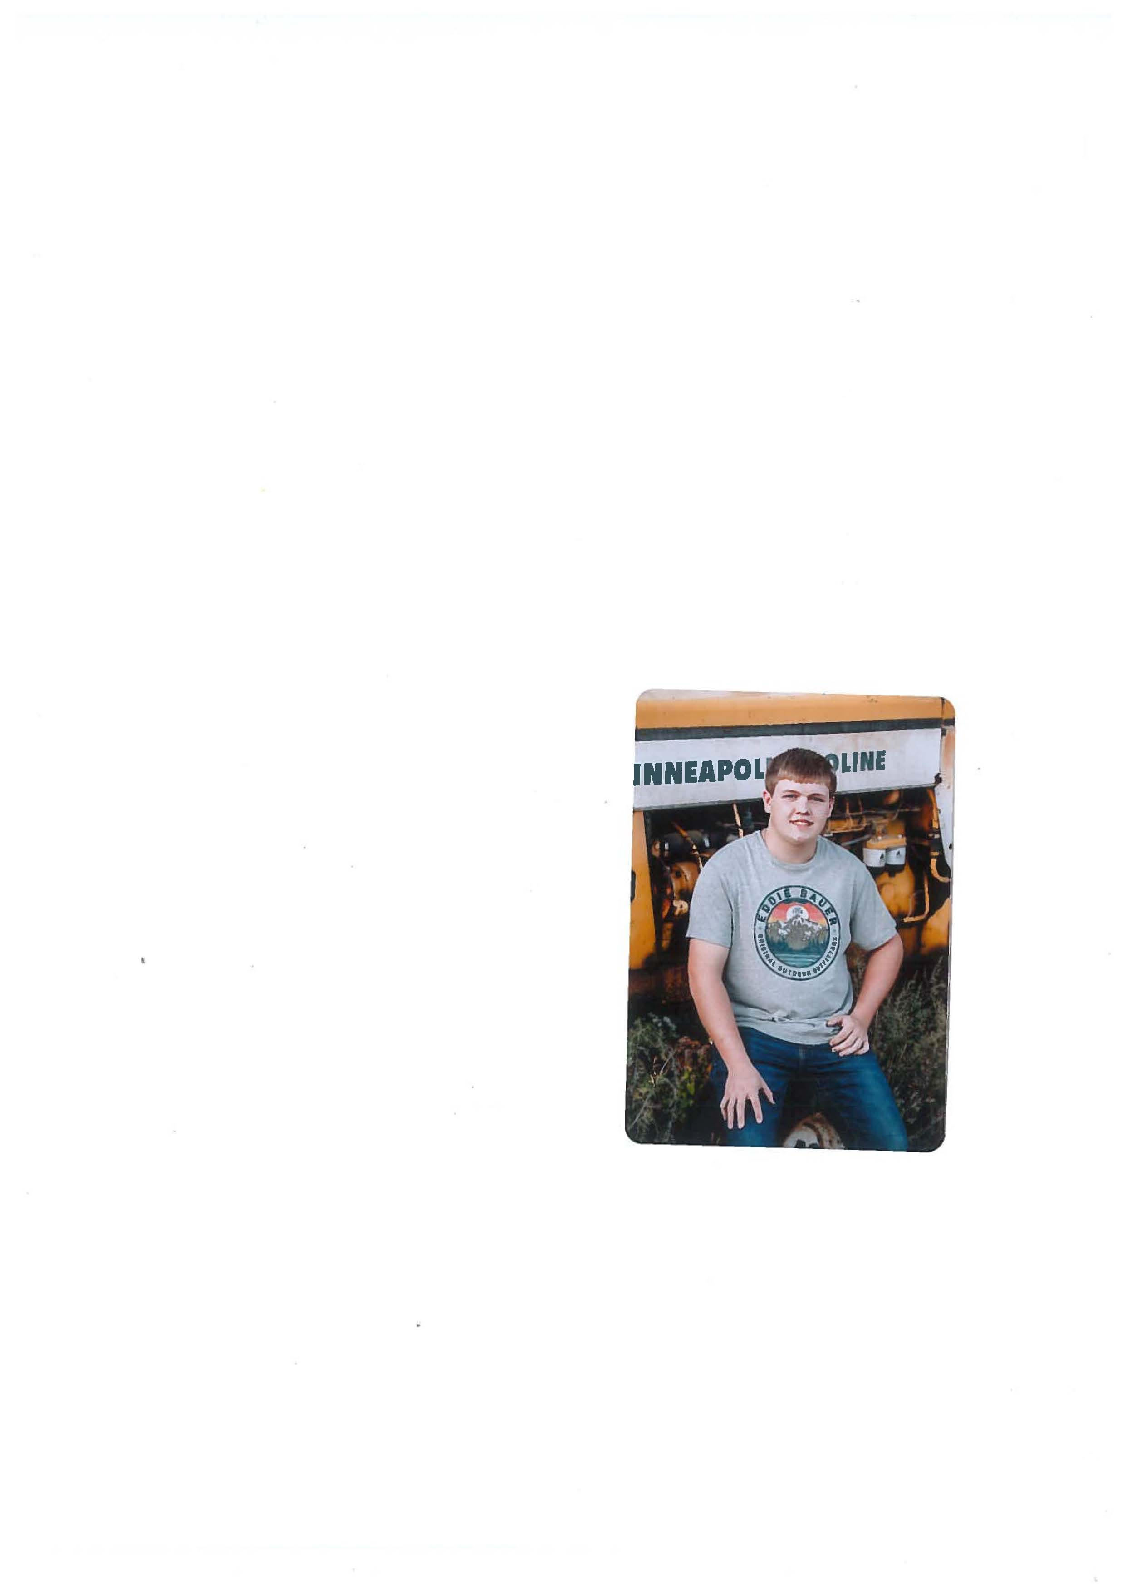

Roberts Conservation Districts Scholarship Winner
Kaden Haubris from Wilmot, SD won our 2023 memorial scholarship. It is a $500 scholarship for Robets County high school seniors who plan to study an agricultural field at a post high school institution. Kaden was active in his local FFA & 4H, he was his class VP, he attended the history fair, science fair, and math contest.

Arbor Day Activities

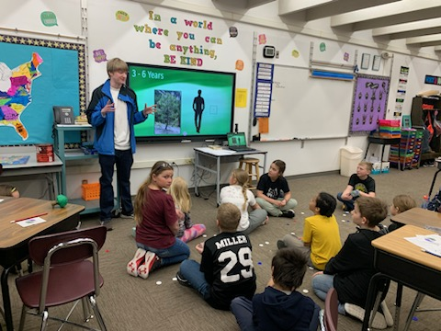
In April, Roberts Conservation District promoted Arbor Day in 3 of the 5 area schools. Around 150 students in the county received a Bur Oak seedling to celebrate. Bur Oaks are a longevity tree with yellow fall color. Arbor Day this year was April 28th, 2023.
The first Arbor Day was established in Nebraska by J. Sterling Morton in 1872. An estimated 1 million trees were planted in NE that day. RCD District Manager, Kristin Pester, and District Technician Carrie Ewalt provided information about Arbor Day history, and the growth stages of a tree. A tree trunk cutting was passed around showing the students the rings and bark of a tree. Our area service forester, Hunter Pecard presented at Summit school.

Pictured: Summit 4th grade with Area Forester presenting: Hunter Pecard.

Arbor Day Poster & Essay Contest
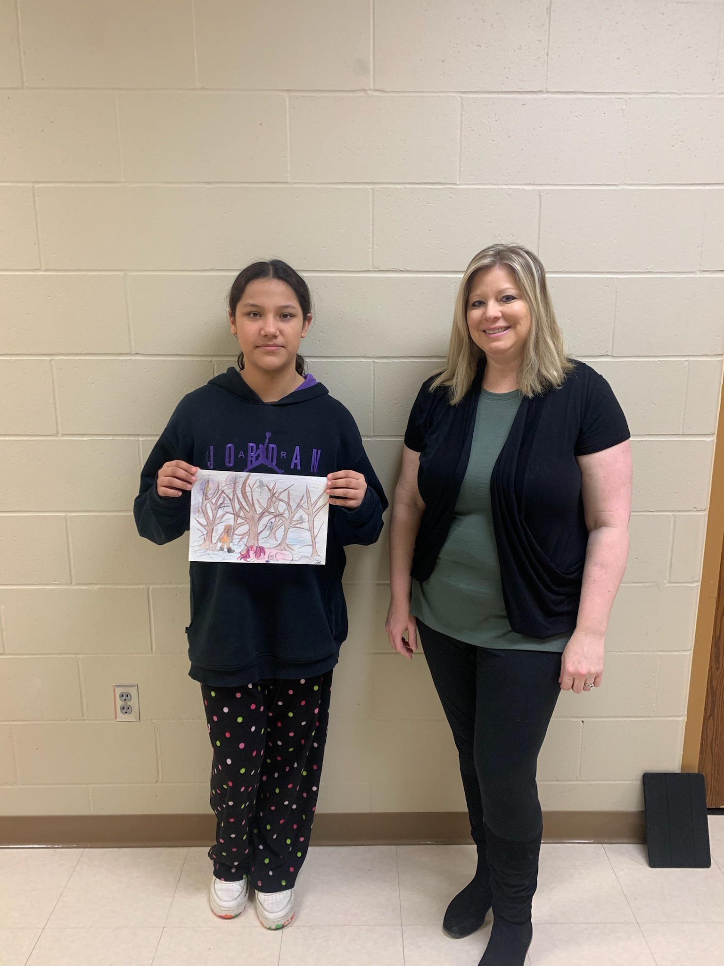
RCD promotes the annual Arbor Day Poster & Essay Contest with all 5th grade teachers.
Sisseton 5th grade submitted 7 poster contest entries. From which, one was chosen as the winner, and presented with a $20 check from RCD. Pictured below on right is Finona Boyd (winner) and her 5th grade teacher, Mrs. Deutsch.

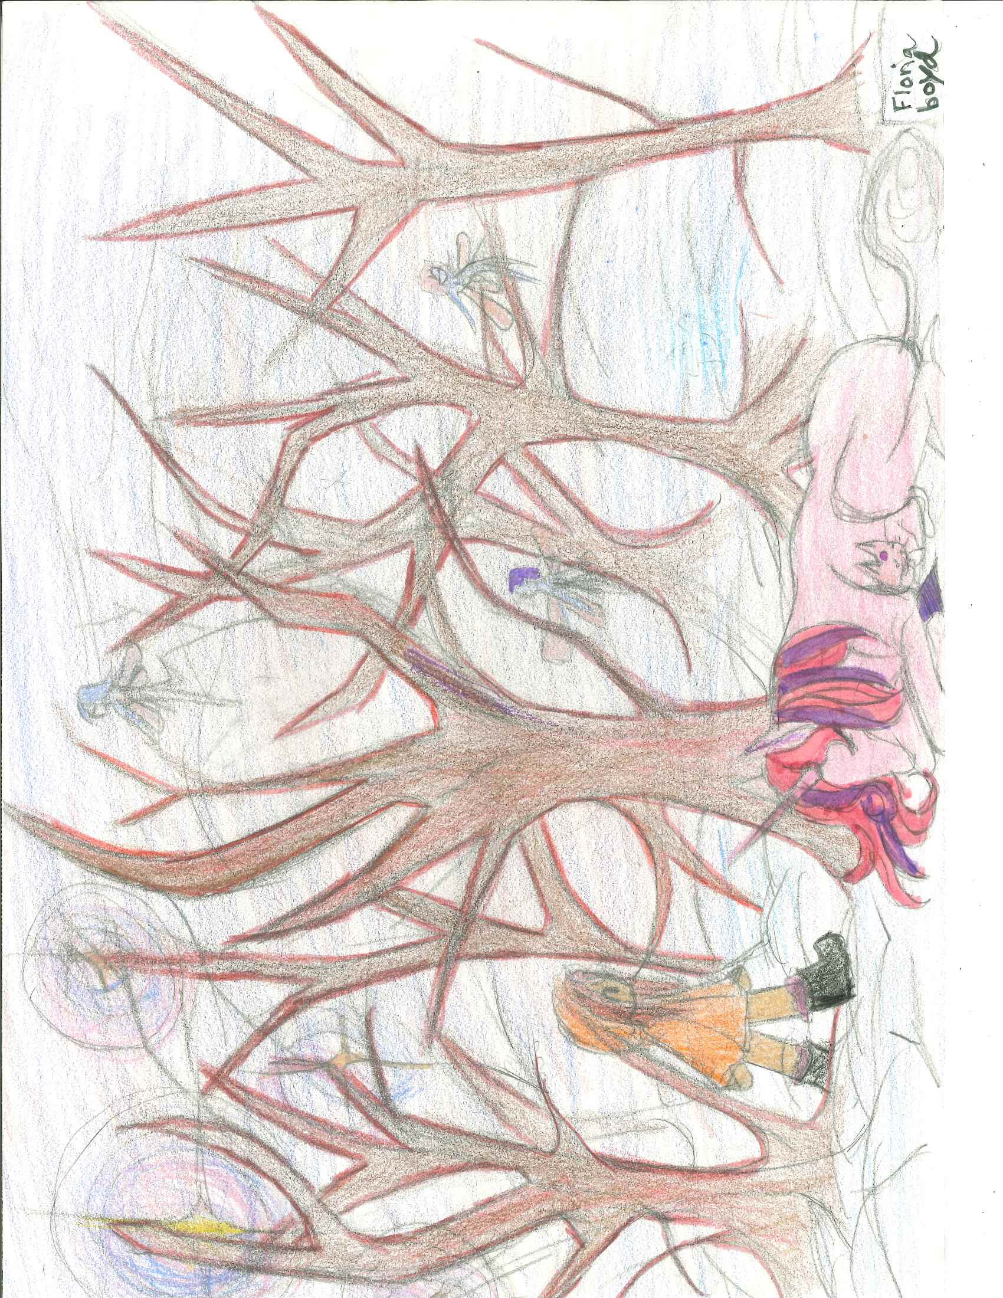
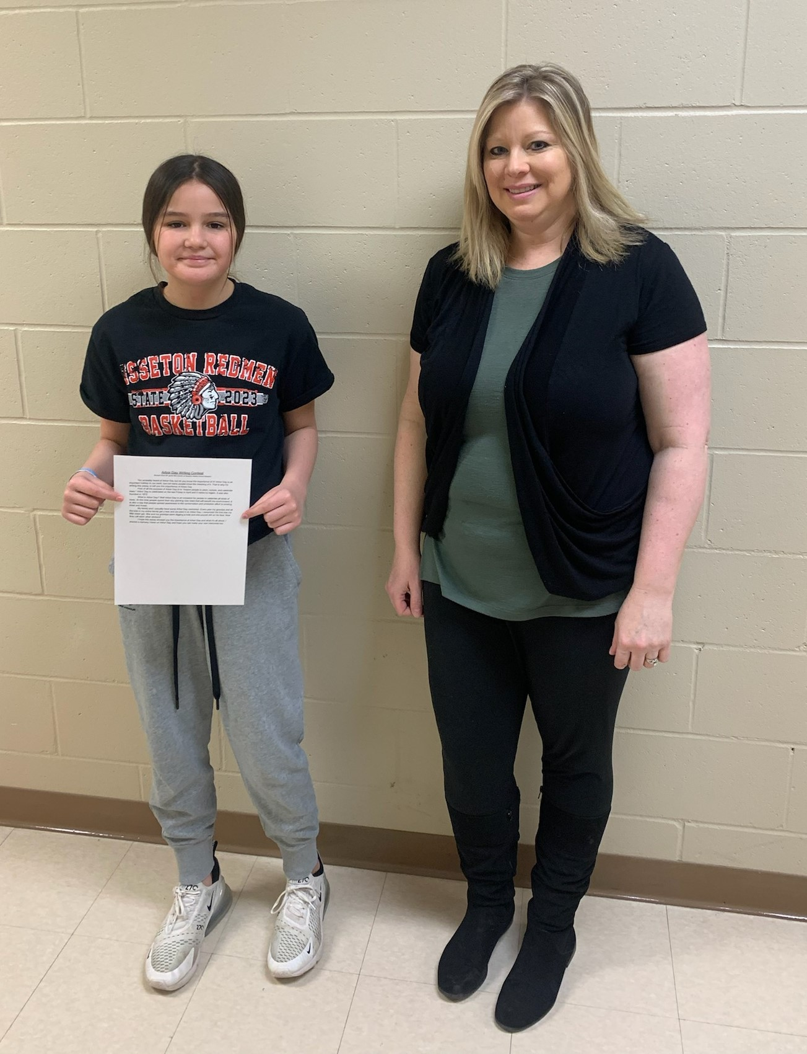
Sisseton’s essay winner was 5th grader Nevaeh Doud. Mrs. Deutsch’s 5th grade class consistently submits essay’s, giving Roberts County at least one submission. Neveah was awarded a $20 RCD check for her efforts. Both are pictured on left.

Outreach Activities
Geology Tour
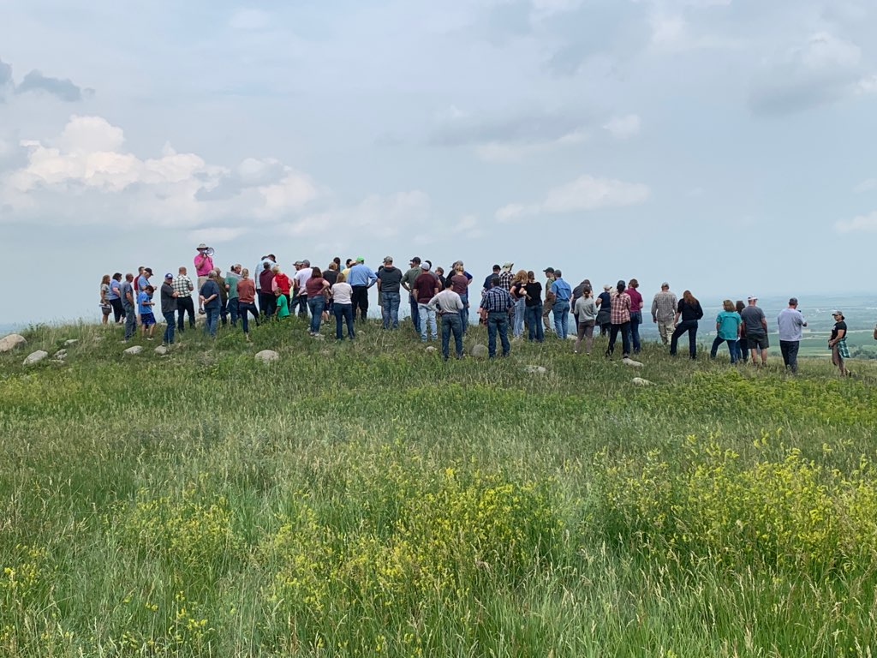
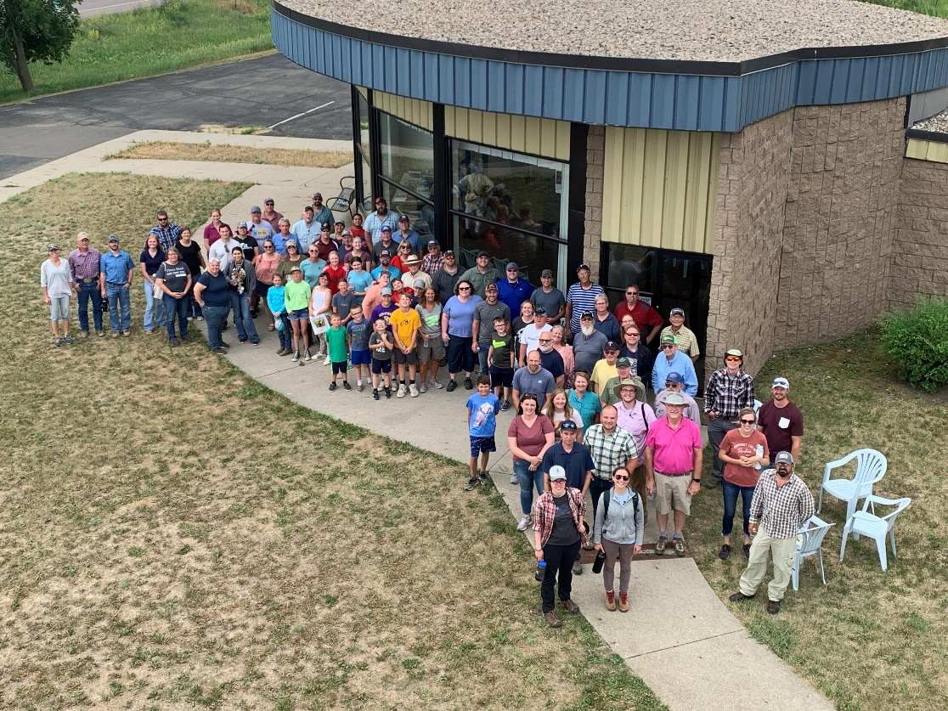
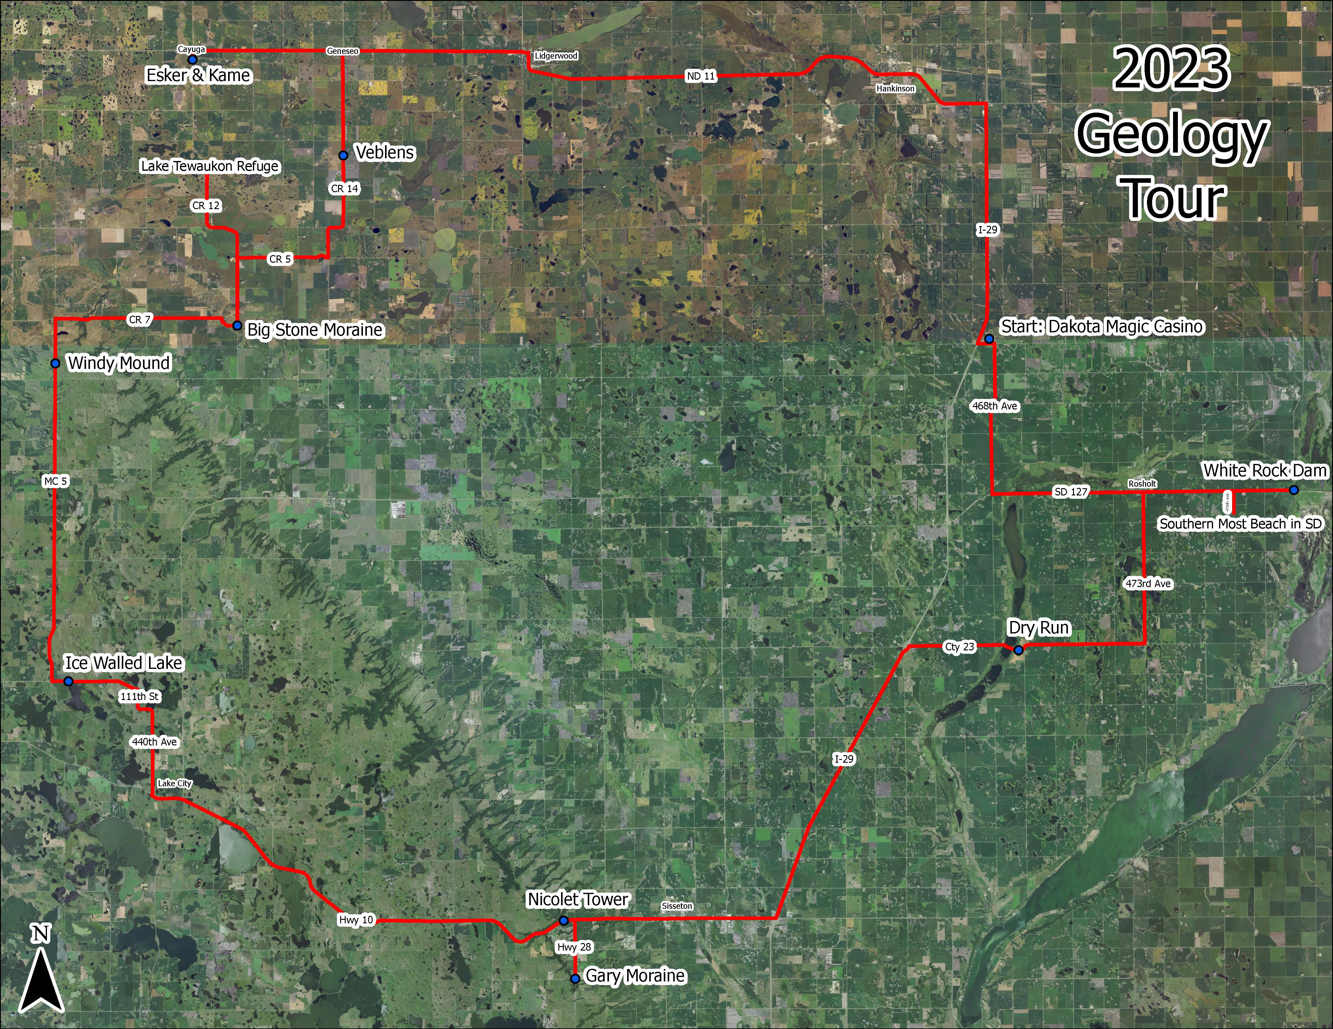
“The 2023 Glacial Lakes Geology Tour sponsored by the Roberts Conservation District was held on Thursday, June 22. The tour highlighted glacial formations in Roberts and Marshall counties in NE South Dakota and features in Sargent County in SE North Dakota.
The guest speaker for the event was Jay Gilbertson, District Manager for the East Dakota Water Development District. Prior to Jay’s 29-year tenure as District Manager, he was employed as a geologist for the South Dakota Geological Survey. Jay led the discussion at each stop of the Geology Tour, delving into the unique characteristics of each feature.”
Author: L. K. Otto-Hanson, NRCS Soil Conservationist, Sisseton Field Office

Outreach Activities
Seed Harvesting Workshop
In early October, RCD partnered with Pheasants Forever on a seed gathering (harvesting) workshop at Nicollet Tower. Roughly 20 participants attended, allowing for an open round table discussion. They learned about different equipment used to harvest, and tips and tricks. Ben Lardy with GF&P walked the grounds with participants, physically harvesting seeds. Below is a photo showing some of the participants viewing seeds they had harvested.

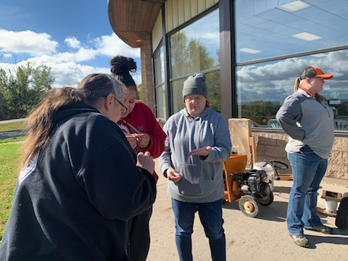
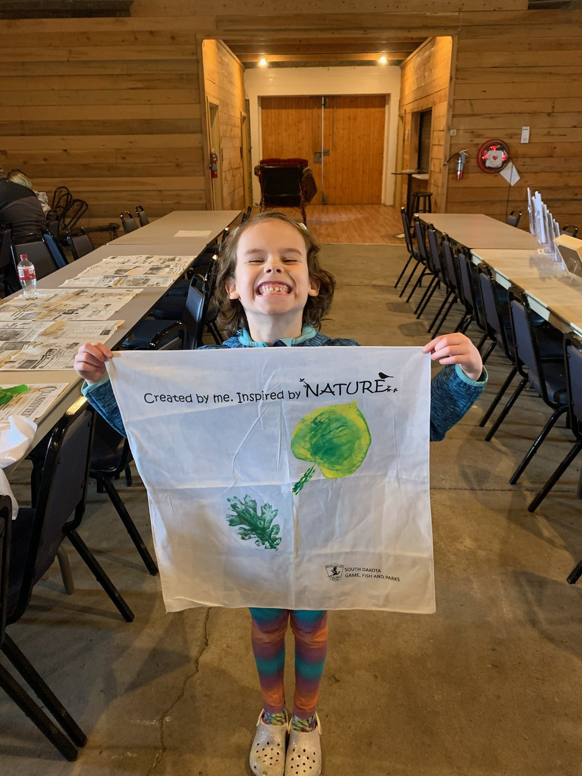

Earth Day
In April, we were asked to assist Dennis Skadsen of the Prairie Coteau Watershed Improvement and Protection Project at the Earth Day event at Fort Sisseton. Although the weather was awful, we had a decent crowd. I hosted a screen-printing station where children painted a leaf form and pressed it onto a towel. Other stations included: pollinator seed balls, wildlife displays, incredible journey, nature art and crafts, coloring contest, and a raffle.

Outreach Activities
Sisseton Highschool & Rangland Days
In September, our resource technician volunteered to assist with the FFA Northeast SD Land and Range Judging Contest in Webster.

Radio Hour
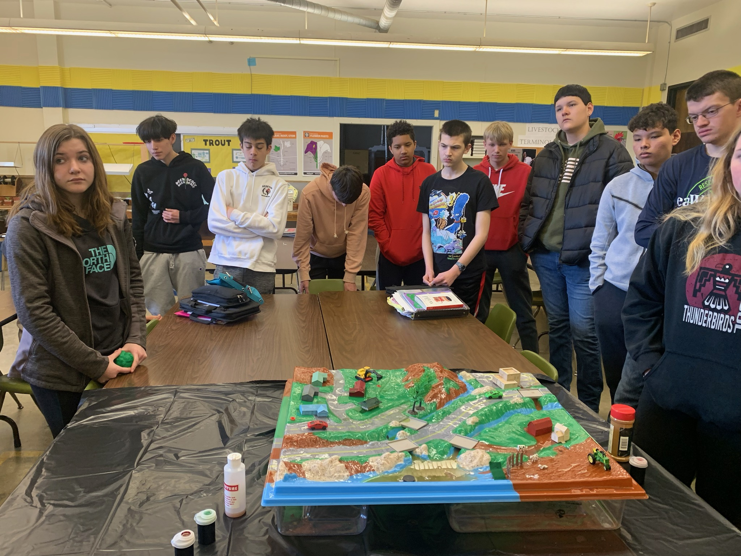
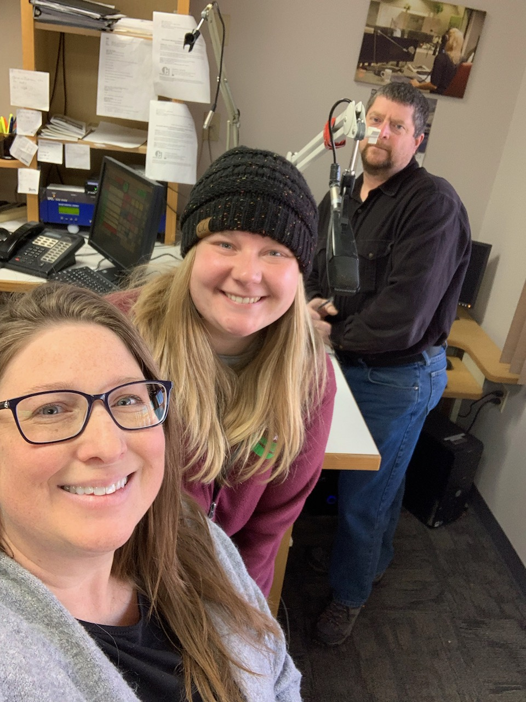
RCD staff participated in the monthly radio hour on B103 Game Fish & Parks Hour on Thursday’s. We showcased the services we provide, trees and shrubs available for sale, new job openings, and timely topics for residents to enjoy. Pictured below are Kristin Pester & Carrie Ewalt with RCD, and NRCS employee Dean Shultz during one of the shows.
Partnering with Prairie Coteau Watershed Improvement & Protection Project leader Dennis Sakdsen, we spoke with two ag classes in Sisseton. We brought along our watershed model and did a presentation with the kids on runoff and the meaning of a watershed.

Outreach Activities
Community Garden
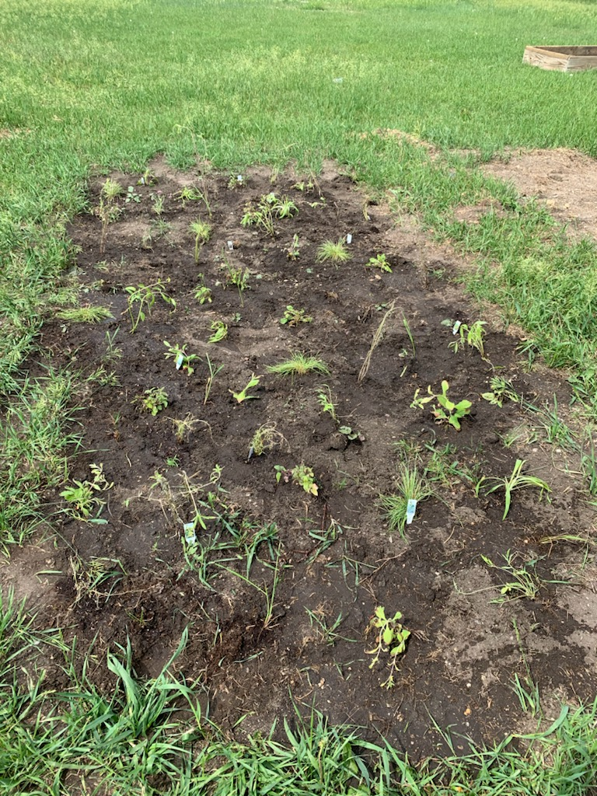
Roberts Conservation District partnered with local interested residents to start a community garden right on main street. Native grass and perennials were planted in our plot to share with all community members. We are excited to see how the garden grows as time progresses.

Seed Exchange
After several meetings at the Sisseton Wahpeton College to collaborate with others on outreach activities, we joined forces to present at a seed exchange workshop. Held in April, the group was able to barter for seeds, learn about seed starting, how to store properly, when/where to plant etc. Below is a photo of one of the tables with our contributions.

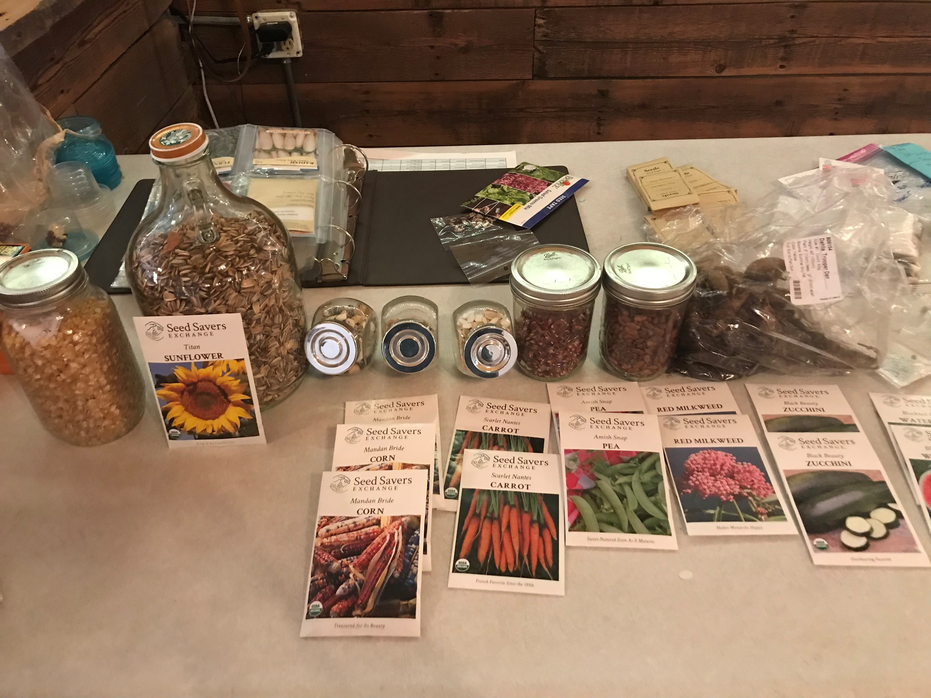

Services Report
- Planted 17 tree sites, totaling 25.8 acres.
- Applied 543 tree tubes.
- Installed 50,664 ft (101 rolls) of weed barrier fabric to newly planted trees.
- Seeded 1,035.06 acres of no till grass and/or alfalfa.
- Provided opportunity to purchase grass seed, cover crop seed, alfalfa, and food plot seed. Sold $87,743.66 in seed sales.
- Rented our Truax drill out to 15 producers, who planted 483 acres with our drill.
- Rented Brillion Drill to 1 producer who planted 10 acres.
- Provided handplant tree sales to over 180 residents.
- Helped sponsor local tours and seminars; along with NRCS, Pheasants Forever, and SD Soil Health Coalition.
- Worked in the Value-Added Ag Day at the State Fair in the Conservation District’s booth.
- Provided donations towards Sisseton 4H raffle items.
- Attended Coteau Area employee meetings.
- Attended area meeting & Legislative supper in Webster.
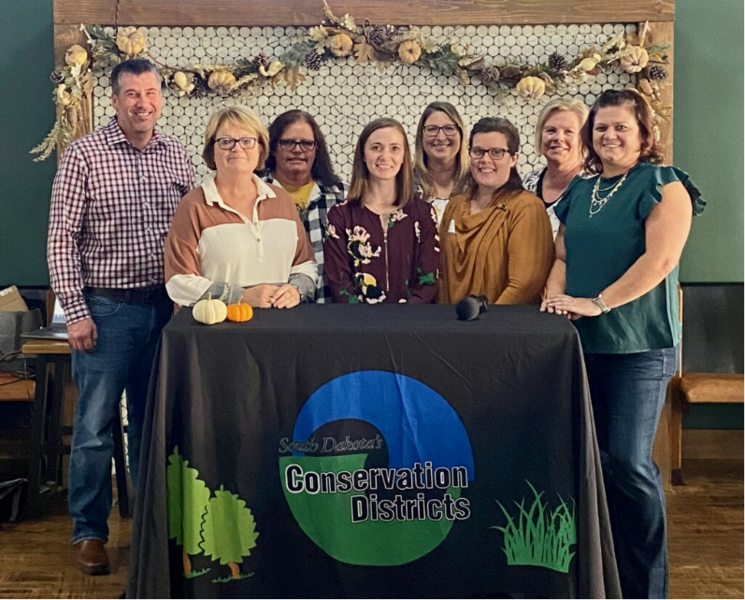
- Attended SDACD Convention in Aberdeen, and SDACDE leadership in Oacoma.
- Attended the SD Soil Health Convention in Sioux Falls.
- RCD has cooperative working agreements between NRCS, State of SD, and SDACD.
- Pay dues for SDACD, SDACD Auxiliary, Tree Research, SDACDE, and NACD.
- Publish 4 quarterly newsletters.
- Maintain website and an active FB presence.
The annual Coteau Area Legislative Banquet was held on October 16th at The Roots in Webster. The picture above includes Josh Wagner- Day County, Peggy Loomis- Hamlin County, Deanna Kunkel-Codington County, Ivy Pazour- Spink County, Kristin Pester- Roberts County, Lori Stevens- Brown County, Jean Fagerland- Marshall County, and Amy Sis- Grant County.

