LWG Success Story
Capture what worked so others can learn from it
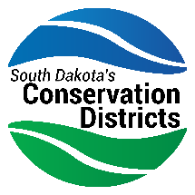
Conservation District |  | Project / Program Name

Date / Time Period |  | Story Written By |  | Contact Info

Success stories are one of the most powerful tools in locally led conservation. They show what's possible, inspire other districts, and help make the case for continued investment. Fill this out when a project wraps up or hits a major milestone.

1. The Story

What was the conservation challenge or need?
What problem were you trying to solve?

What did your district do?
Describe the project or program in plain language - what actions did you take?

What changed because of it?
What's different on the ground now? Be specific.

2. By the Numbers
Numbers make your story credible. Include acres, landowners, dollars, miles - whatever you measured.

What We Measured | The Number | Why It Matters

3. In Their Own Words
A quote from someone who was part of it - a landowner, partner, board member, or community member.

“ | Quote from a landowner, partner, or community member  - Name, Title / Role

4. Partners Who Made It Happen
Credit the people and organizations that helped. This strengthens relationships and shows the locally led model in action.

Partner / Organization | Their Contribution

5. What's Next

How does this build on itself?
What's the next step, follow-on project, or opportunity this success opens up?

Photos & Media
Do you have photos, video, or media coverage of this project? Paste or link them below. Visuals make success stories much more shareable.

Help others learn from your experience by sharing your locally led story with SDACD.

